*Preference for presentation  Poster or  Oral communication (both could be indicated)*

**15th International Workshop on Radiation Damage to DNA**

[Jean-Luc Ravanat](#author" \o "Underline presenting author)*, Elise Dumont2, Thierry Douki1, Jean-François Constant3, Joanna Timmins4

1INAC/SyMMES/CIBEST, UMR 5819 CEA-CNRS-UGA, CEA Grenoble, 17 rue des Martyrs F-38054 Grenoble cédex 9 France, 2 Laboratoire de Chimie, Univ Lyon, ENS Lyon, CNRS UMR 5182, 46 allée d’Italie, 69364 Lyon, 3Université Grenoble Alpes, DCM UMR 5250, F-38000 Grenoble, France, 4Université Grenoble Alpes, Institut de Biologie Structurale, F-38044 Grenoble, France; CNRS, IBS, CEA, F-38044 Grenoble, France

[15iwrdd@sciencesconf.org](#mail" \o "indicate e-mail address of presenting author)

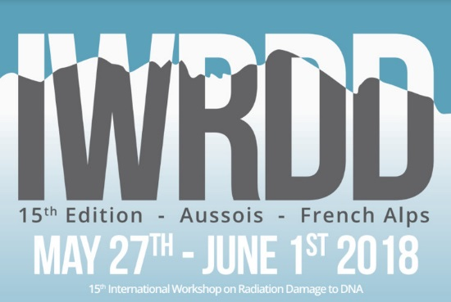The fifteenth edition of the international workshop on Radiation Damage to DNA will be held in Aussois, France, from May 27th to June 1sty, 2018. This workshop will bring together physicists, chemists and biologists interested in the field of radiation-mediated DNA damage and their biological consequences.

The first edition of this biennal international workshop took place in 1988 (30 years ago!) in Mulheim Germany organized by Dr Schulte-Frohlinde and Von Sonntag. Since, this meeting was organized every two years in all continents and once in France in Orléans in 2001 organized by Dr Mélanie Spotheim-Maurizot. Last edition took place in Melbourne, Australia under supervision of Roger and Olga Martin.

Since the first edition, special attention has been paid to the involvement of young scientists, mostly through the financial support dedicated to young investigators. Young investigators could apply for awards, more information is given on the website of the meeting: <https://15iwrdd.sciencesconf.org>

We hope you will be able to join us for the 15th edition of the International Workshop on Radiation Damage to DNA.

*Please do not change the font and size of the different sections!*

*The abstract (including title authors addresses and text) should not be longer than one page!*

*[Reference](#reference" \o "References could be indicated)*

<https://15iwrdd.sciencesconf.org>

**Keywords**: *Please indicate at least 3 (up to 5) keywords that will allow the scientific committee to classify your presentation according to the topics indicated in the tentative program*.